Modeling Methodology

The modeling of state-level HPI is divided into two phases:

1) Drift modeling
2) Volatility modeling.

Both the phases are explained, with analysis and results for a set of states, as follows:

Phase#1: Drift Modeling

This stage consists of the following steps:

- Data preparation
The period selected for modeling is January 1998 to June 2008.
  - Missing value treatment
  - Exploratory data analysis
    - Transformations
Stationarity of the response and predictor variables was tested statistically using the Augmented Dickey-Fuller test and checked graphically by looking at the autocorrelations plot.
After this initial analysis of the data, a simple returns transformation was carried out on the response and predictor variables for modeling & forecasting the HPI data. A simple returns transformation induced stationarity in the series. See Figure 1.b for results of the independent variables and the two response variables of Nevada and Arizona HPI.

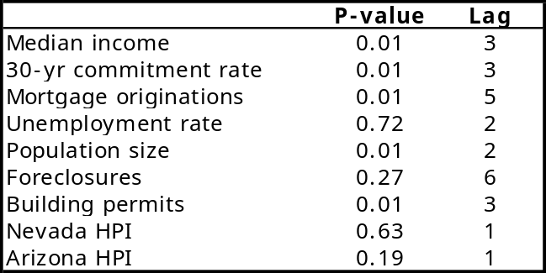

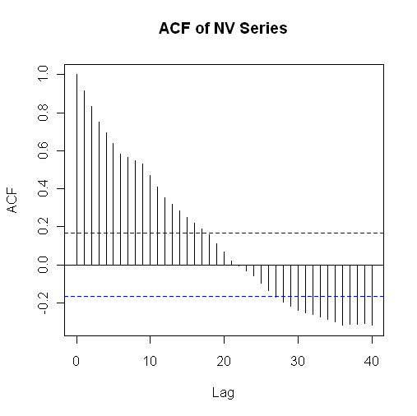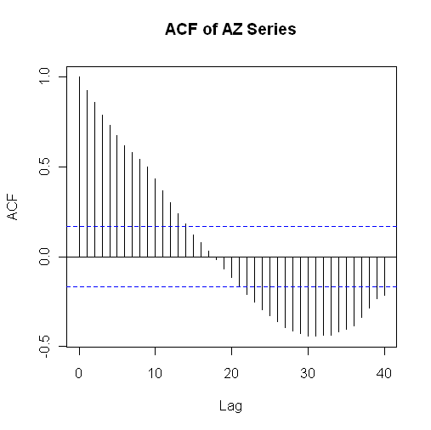
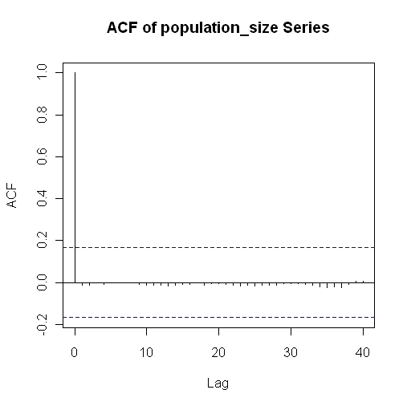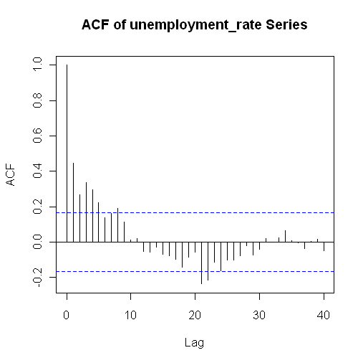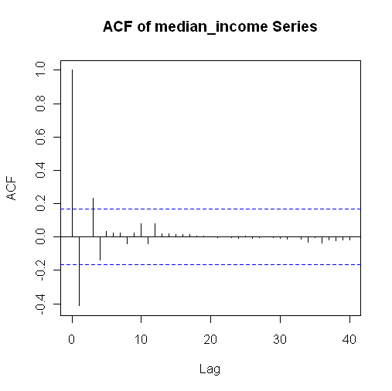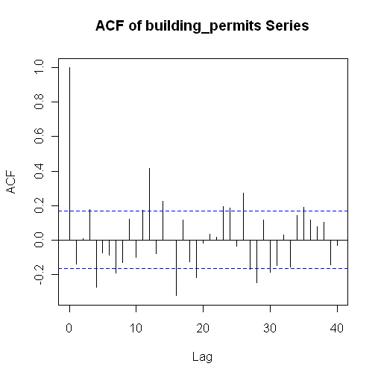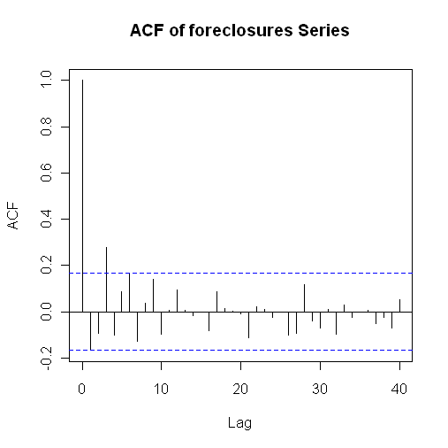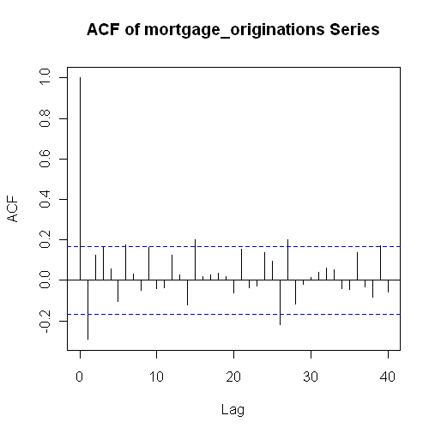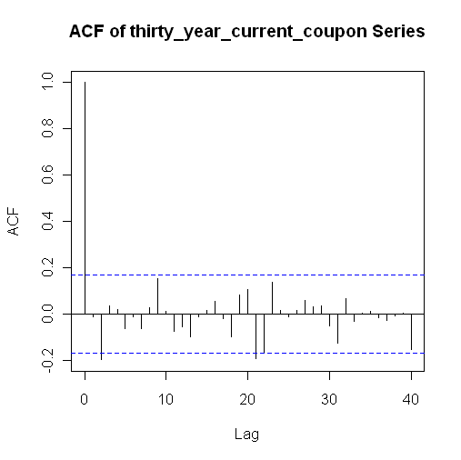
Figure 1.b: ADF results and ACF plots for
the predictor variables and NV and AZ

  - Identification of leading and lagging indicators
    - Cross correlation analysis: This analysis was carried out to identify the leading and lagging indicators and the lags at which these indicators showed a high correlation with the HPI index. This step is crucial to capture true dependencies between the predictors and the response variable in the modeling stage, and develop a robust fit.
Figure 1.c shows the lags showing significant correlations with the HPI simple returns data for the state of Nevada and Arizona.

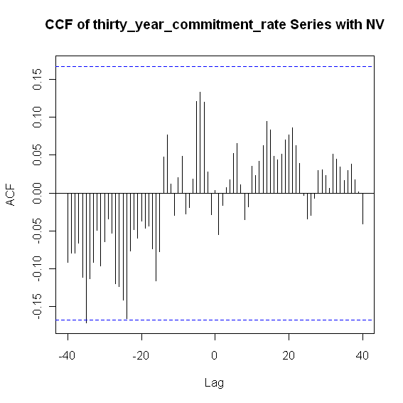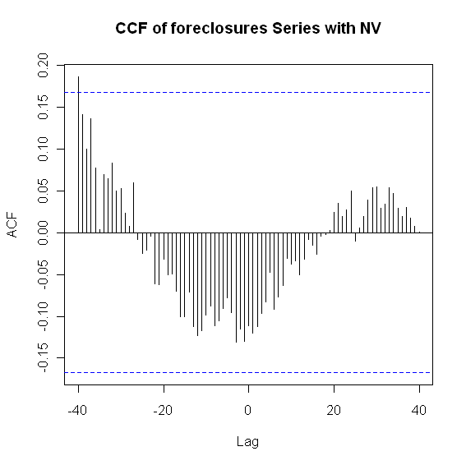
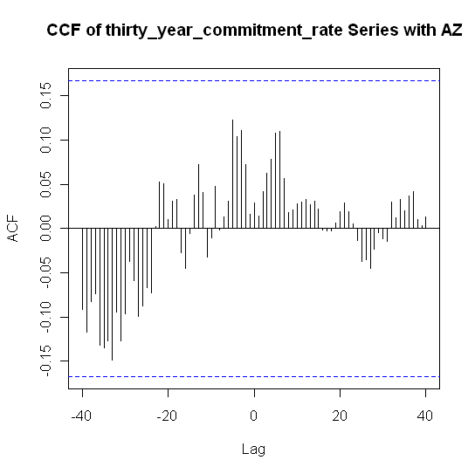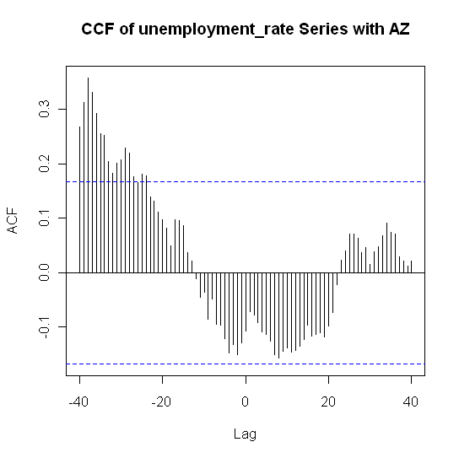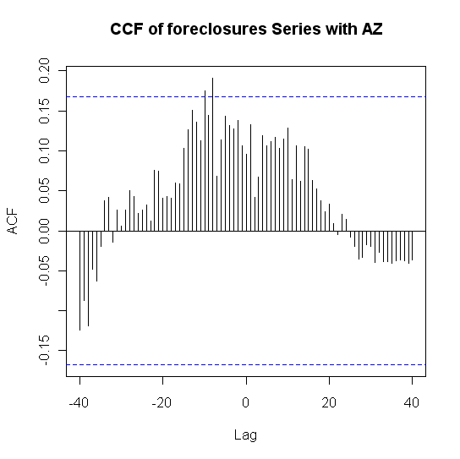
Figure 1.c: CCF plots of NV and AZ with lagged variables

- Multiple regression analysis
  - Identification of the significant predictors:
Once the leading and lagging indicators were identified, a multiple regression model was developed for each state separately. The modeling scheme employs a step-by-step inspection of p-values in the each regression output to identify the significant predictors and come up with a parsimonious model with highest explanatory power as measured by the R² values. At each iteration, the most insignificant variable, measured by the largest p-value, was dropped; then the model was refitted without the dropped parameter. Following results show the iterative and final models developed for Nevada and Arizona.

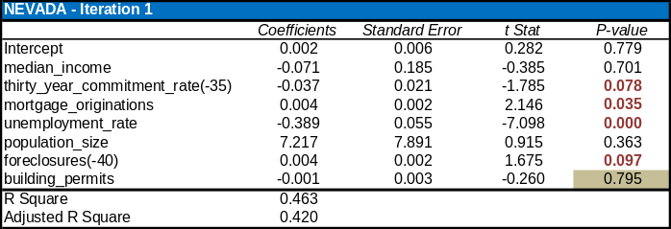
Drop “building permits” and re-estimate

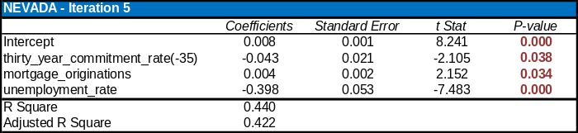

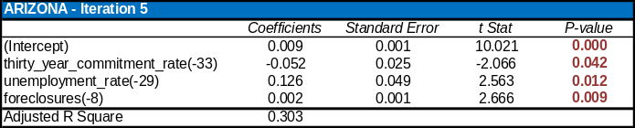

- Analysis of residuals:
  - Validation of assumptions of multiple regression: It is imperative to check that the final regression model satisfies the basic premises of the multiple regression framework to ensure that the regression is not spurious. The following checks are employed to test the validity of the drift models:
    - Homoskedasticity of residuals i.e. the residuals must have a constant variance.
    - The final conclusion from the regression model must not be driven by influential outliers in the data. If outliers are detected then the data should be appropriately conditioned to get a robust fit. There are no outliers observed in the diagnostic plots.
    - The residuals must be normally distributed. This is checked using the QQ plot as shown below for the modeled states. The points lie along the straight line, which clearly confirms normality of residuals for the fitted model.

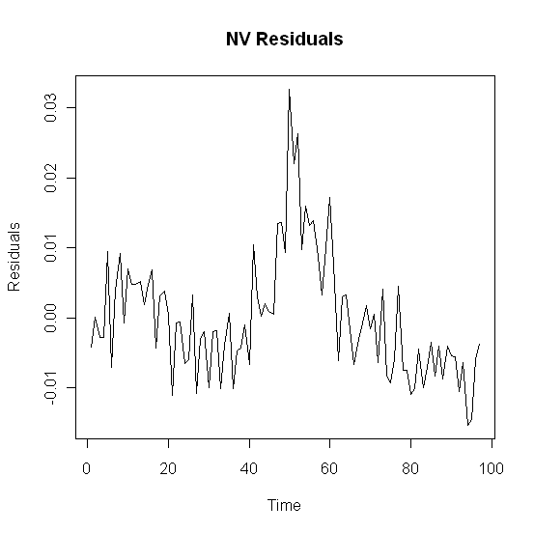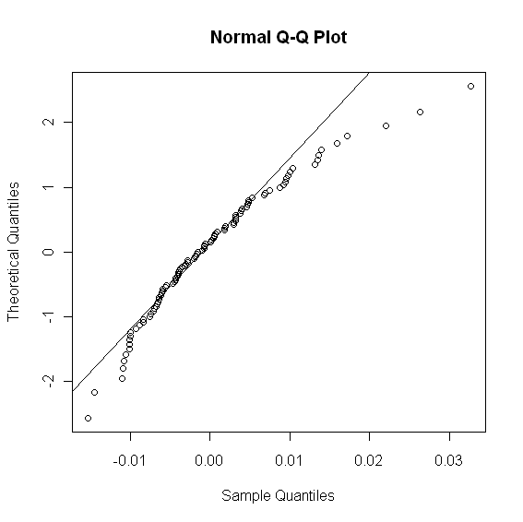
Figure 3.a.i: Nevada regression residual analysis
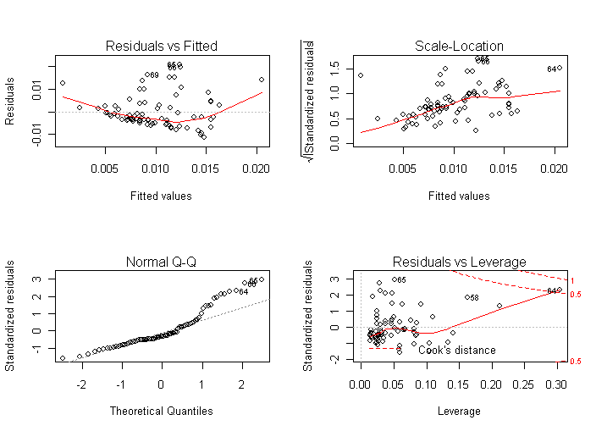
Figure 3.a.ii: Arizona regression residual analysis

    - There should be no autocorrelation observed in the residuals. The ACF plots of the residuals are created to check for independence. If there are no significant autocorrelations observed, as seen in Figure 3.a.iv, then there is no need to model the innovations component for this series. However if there are significant autocorrelations, as seen in Figure 3.a.iii, then the residuals are correlated, which implies dependence amongst residuals. This calls for modeling the innovations, which takes us to phase#2 of the modeling methodology.

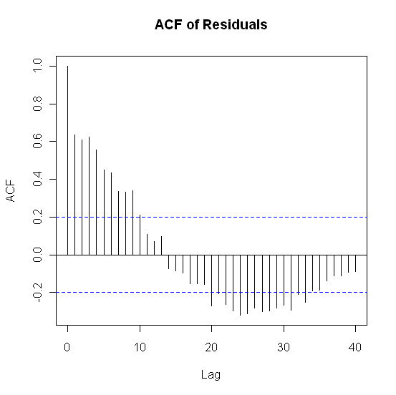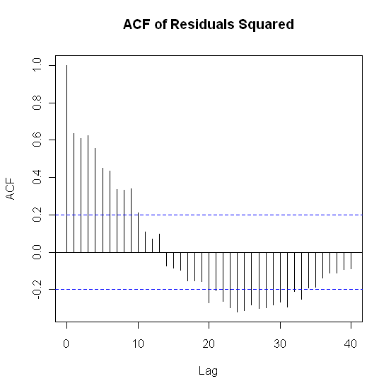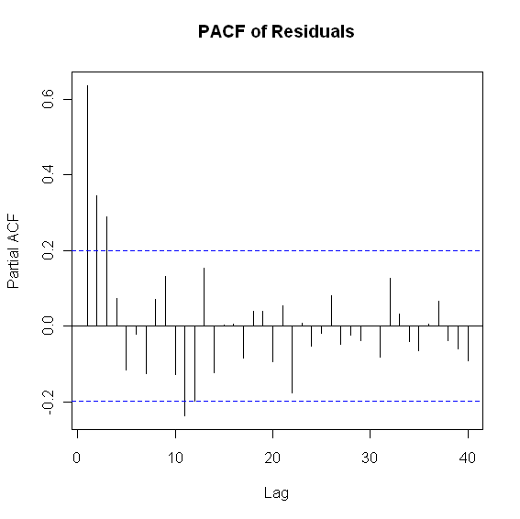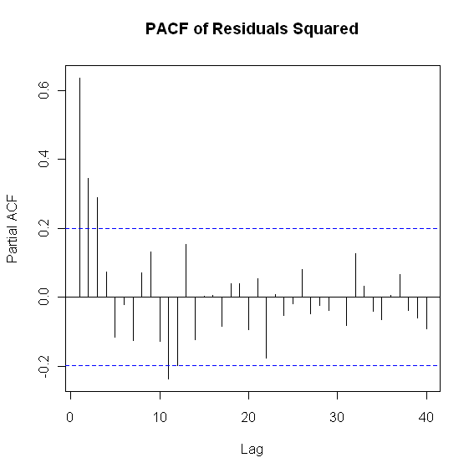
Figure 3.a.iii: ACF of residuals and squared residuals for NV

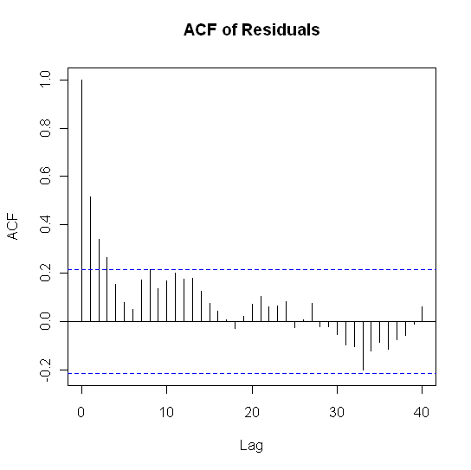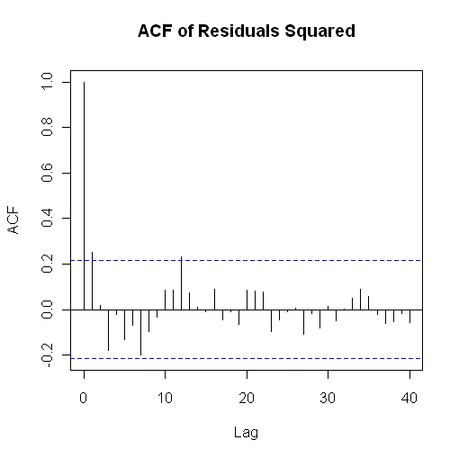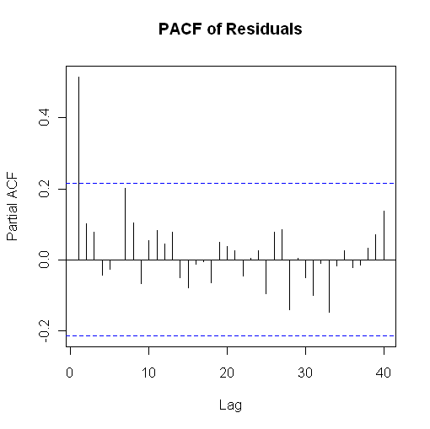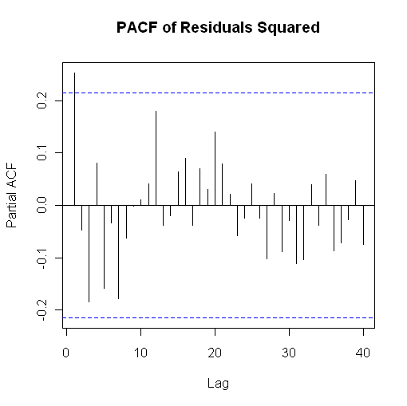
Figure 3.a.iv: ACF of residuals and squared residuals for AZ

Phase#2: Innovations (Volatility) Modeling

- ARFIMA model fitting
  - Determination of model order
    - Time series, ACF, PACF and EACF plots are examined to evaluate test the series for unit root non-stationarity and to choose appropriate model order for the time series of the residuals series in question. Trial and error based approach is employed to determine the most parsimonious model.
  - Analysis of residuals
    - Once the ARMA model is fitted the residuals are tested for autocorrelations. Box-Ljung test is carried out on the residuals and squared-residuals to test for autocorrelations and arch effects. The results of this test for Nevada are given in the Figure 4.b.i. If autocorrelations are observed, then we re-fit the model using different orders. If ARCH effects are observed, based on the result of Box-Ljung test on the squared residuals, then we move to fit the ARFIMA-GARCH model to model the innovation component. This is the case for Nevada. See Figure 4.b.ii for the results of the ARIMA model fitting.
> Box.Ljung.test(residuals, lag =12, adj.DF =12)
Q(12) P-value df
234.3443 0 12

> Box.Ljung.test(residuals^2,lag =12, adj.DF=12)
Q(12) P-value df
54.6187 0 12

Figure 4.b.i: Box-Ljung test results on the residual and residual squared series. The small p-value for the squared residual series is an indication of ARCH effects.

Series: residuals
ARIMA(0,1,1)

Call: auto.arima(x = residuals)

Coefficients:
ma1
-0.6094
s.e. 0.0708

sigma^2 estimated as 3.634e-05:
log likelihood = 354.24
AIC = -704.48 AICc = -704.35 BIC = -699.35

  - ARFIMA/GARCH fitting

Phase#3: Validation, testing & forecasting

Figure 4.b.ii: ARIMA results for Nevada residual analysis.
An ARIMA(0,1,1) model was fit, implying that an MA(1) model works on the first differenced series of the
Nevada regression residuals.

Once the model is finalized by carrying out the Phase#1 and Phase#2, we test the model for its validity and how well it forecasts the HPI returns from which we can back transform to get the actual HPI forecasts. We forecast the data held back as the validation set to assess the accuracy of the model and to document the forecast errors. The model prediction errors for the Nevada are documented in Table 5. If these prediction errors are within tolerable limits we can finalize on these models and use them to forecast long run HPI estimates.

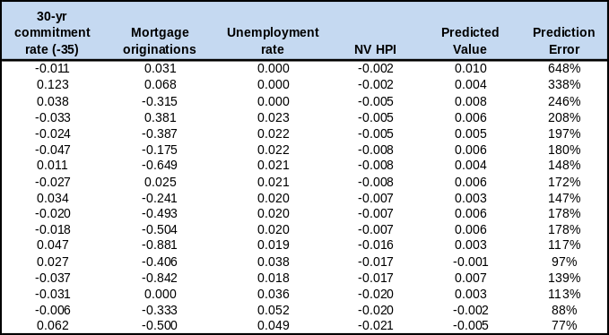
Table 5: Backtest of regression model for Nevada
using forecasts and prediction error.

